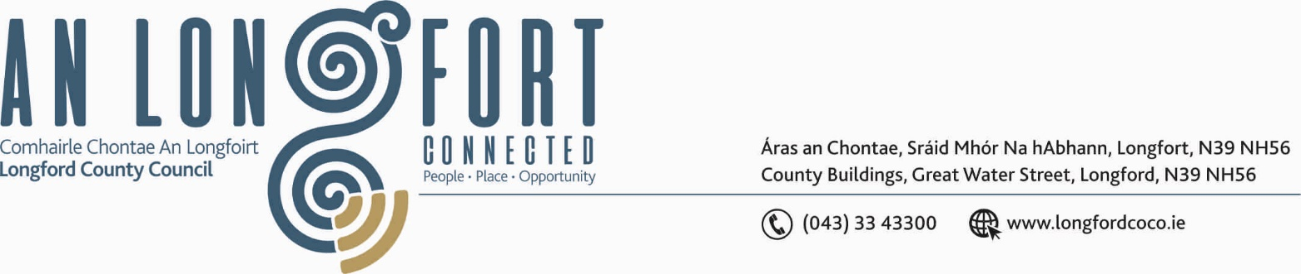

LONGFORD MUNICIPAL DISTRICT

Please bring your iPads to all meetings, fully charged, to allow for access to meeting supporting documentation.

Please note Time of Meeting – 2.00 p.m.

21st May 2020.

To: Each Member of Longford Municipal District.

Dear Member,

You are requested to attend Meeting of Longford Municipal District to be, held in the Sports Hall, Leisure Centre, Albert Reynolds Peace Park, Longford on Wednesday,
27th May 2020 at 2.00 p.m. to transact business, as set out on the Agenda hereunder.


Yours sincerely,

_______________
Anne Lee,
Meetings Administrator.

AGENDA

Prayer before meeting.

- Confirmation of Minutes of meeting of Longford Municipal District held on
the 22nd April 2020 - enclosed.

- Matters arising from Minutes.

- Declaration of Interest by Members.

- Management Report - to follow.

- Report from the Environment Section on efforts to address Illegal Dumping within the Longford MD area.

- Notices of Motions, submitted by Councillors, as listed hereunder –

Councillor Uruemu Adejinmi
“I call on Longford County Council to provide ‘No Dumping’ signage at Clonbalt Woods, as the area has become a dumping ground for grass cuttings in the recent past.”
“I call on Longford County Council to refurbish the footpath on the Drumlish Road, just after the N4 Roundabout. It has fallen into disrepair and is becoming hazardous for pedestrians.”

- Notice of Motion submitted by Councillor Seamus Butler to the March meeting of the
County Council -

“That Longford County Council should provide serviced overnight facilities for RUVs and camper vans. This will mitigate against the blight of such vehicles causing nuisance by parking in public areas such as Clondra Harbour. It will also attract a category of tourist that is not currently catered for adequately in the County.”

It was agreed that this Notice of Motion be referred to each of the Municipal Districts for consideration.

- A.O.B.



